

OCR-Based Assistive Glasses for Visually Impaired Individuals

Submitted by:
23BCE7300 - Adithya Mohanan (CSE)
23BCE7381 - Devanand M (CSE)
23BCE7443 - Aswin M (CSE)
23BCE7477 - Yeadhu Krishna P (CSE)
23BCE7564 - Abhinav SP (CSE)
23BEC7234 - V Raj Narayanan (ECE)

Under the Guidance of:
Prof. Tauseef Khan
Department of SCOPE, VIT-AP University
Date of Submission: November 5, 2025

Table of Contents
S. No. | Section | Page No.
1 | Introduction | 1
2 | Software Overview | 2
2.1 | PaddleOCR | 2
2.2 | OpenCV (Open Source Computer Vision Library) | 3
2.3 | GoogleTranslator | 3
2.4 | Groq API (Text-to-Speech Conversion) | 4
3 | Hardware Components | 5
3.1 | ESP32-CAM AI Thinker | 5
3.2 | Battery Management System (BMS) | 6
3.3 | Step-Down (Buck) Converter | 6
3.4 | PAM8610 Stereo Audio Amplifier | 7
3.5 | Li-Ion Battery (3.7V 250mAh) | 8
4 | Working Principle | 9
5 | Circuit Diagram | 10
6 | Code | 10
7 | Conclusion | 11

1. Introduction
This project aims to design and develop smart assistive glasses that can recognize, translate, and audibly read text from the surrounding environment.
The system utilizes Optical Character Recognition (OCR) combined with real-time translation and speech synthesis to help visually impaired or optically challenged individuals understand written information such as signs, labels, and documents.
The glasses employ an ESP32-CAM module to capture live images and transmit them wirelessly to a local processing system running OCR and translation algorithms.
Recognized text is then converted to speech and played through an earphone connected to an amplifier circuit.
This solution promotes independence, accessibility, and multilingual communication through embedded AI and IoT technologies.

2. Software Overview
The software stack integrates four primary components: PaddleOCR (for text recognition), OpenCV (for image capture and processing),
GoogleTranslator (for translation), and Groq TTS (for text-to-speech conversion).

2.1 PaddleOCR
PaddleOCR is an open-source deep learning-based text recognition engine developed by Baidu. It detects and extracts text from images in multiple languages with high accuracy, processing frames captured from the ESP32-CAM stream and outputting recognized English text.

2.2 OpenCV (Open Source Computer Vision Library)
OpenCV is a real-time computer vision and image processing library used for connecting to the ESP32-CAM stream, capturing video frames, and handling image operations. It displays live video, allows frame capture using the spacebar, and passes frames to PaddleOCR for text extraction.

2.3 GoogleTranslator
GoogleTranslator, from the deep_translator Python library, translates recognized text into the target language (Hindi). This module enhances multilingual accessibility for non-English speakers by translating text before it is passed to the TTS system.

2.4 Groq API (Text-to-Speech Conversion)
The Groq API provides text-to-speech functionality, converting translated text into natural-sounding audio files. It uses a pre-trained model to synthesize speech and outputs it as a WAV file that can be played through the amplifier circuit.
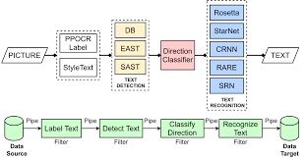

3. Hardware Components
The hardware section consists of all electronic components used to make the OCR glasses functional and wearable.
Each module has a specific role in image capture, power regulation, or audio output.

3.1 ESP32-CAM AI Thinker
The ESP32-CAM AI Thinker module acts as the vision and connectivity unit. It captures real-time video using the onboard OV2640 camera and streams it over Wi-Fi for OCR processing.

3.2 Battery Management System (BMS)
The Battery Management System ensures safe operation of the rechargeable lithium-ion batteries. It protects against overcharging, over-discharging, and short circuits while managing battery health and balance.

3.3 Step-Down (Buck) Converter
The step-down converter reduces the battery voltage (7.4V) to a stable 5V required by the ESP32-CAM and amplifier modules. It provides consistent power output and ensures circuit stability.

3.4 PAM8610 Stereo Audio Amplifier
The PAM8610 is a 10W dual-channel Class-D amplifier used to drive earphones or small speakers. It amplifies the audio signal generated from the Groq TTS system for auditory feedback.

3.5 Li-Ion Battery (3.7V 250mAh)
The 3.7V 250mAh Li-ion battery provides portable power to the entire circuit through the step-down converter. It ensures compact and efficient energy delivery for wearable use.

4. Working Principle
1. Capture Phase: The ESP32-CAM captures live video frames and sends them to the processing system.
2. OCR Phase: PaddleOCR extracts text from captured frames.
3. Translation Phase: GoogleTranslator translates the extracted text into the target language.
4. Speech Phase: Groq API converts the translated text into a WAV audio file.
5. Output Phase: The audio file is played through the PAM8610 amplifier and delivered via an earphone.

Circuit Diagram

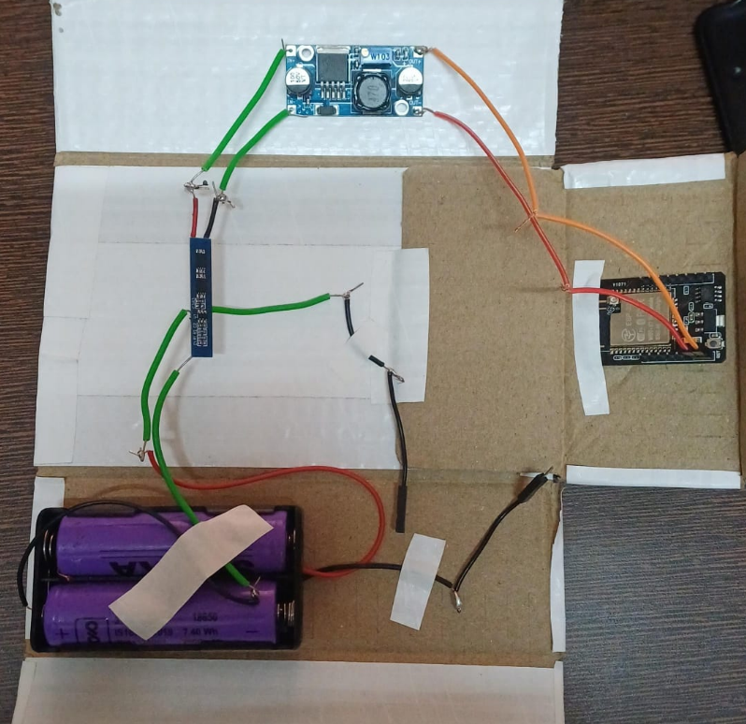

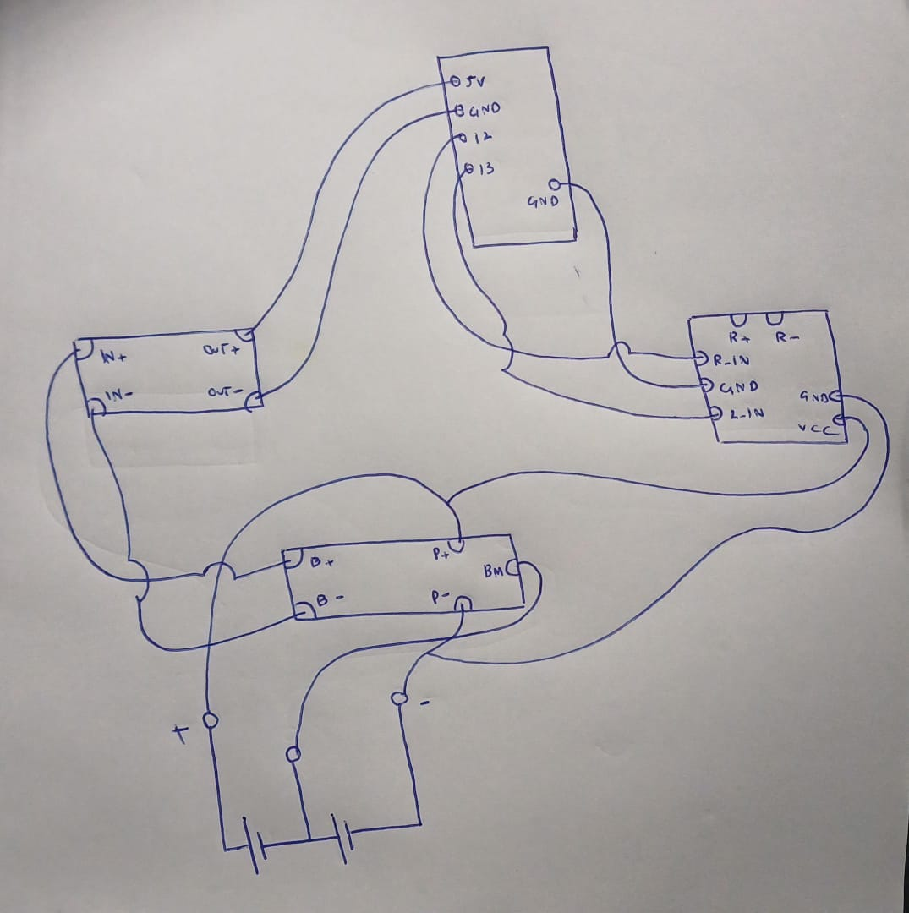

Code

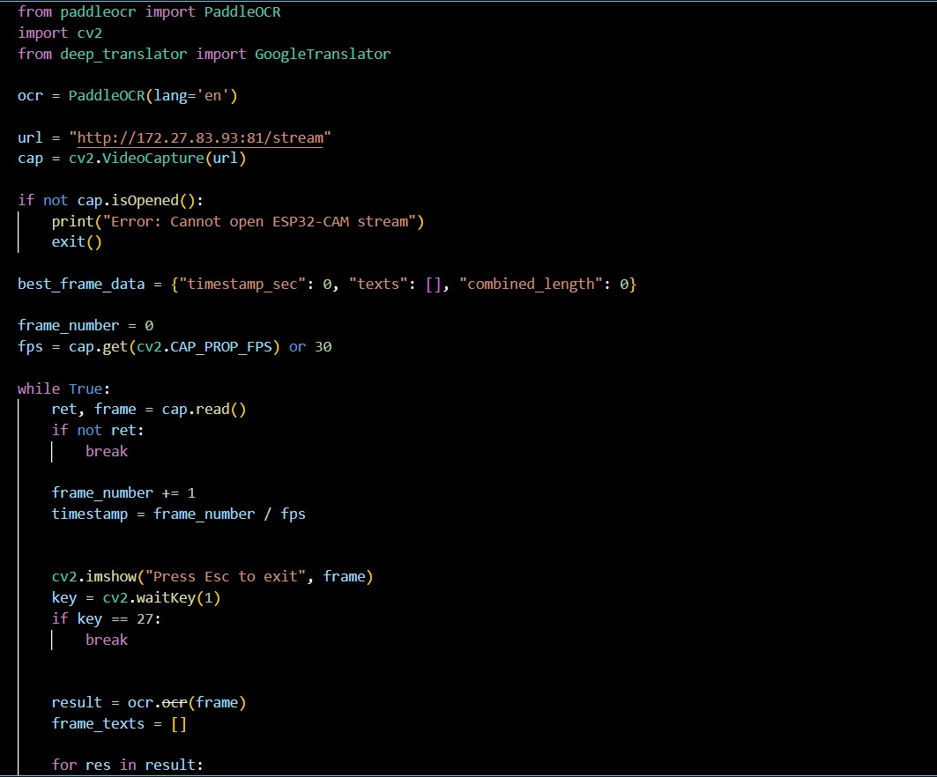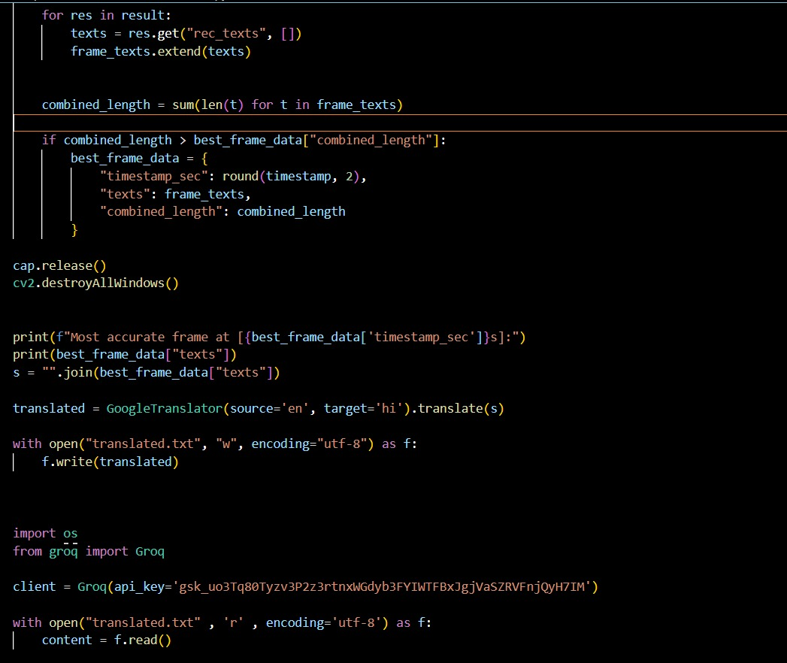

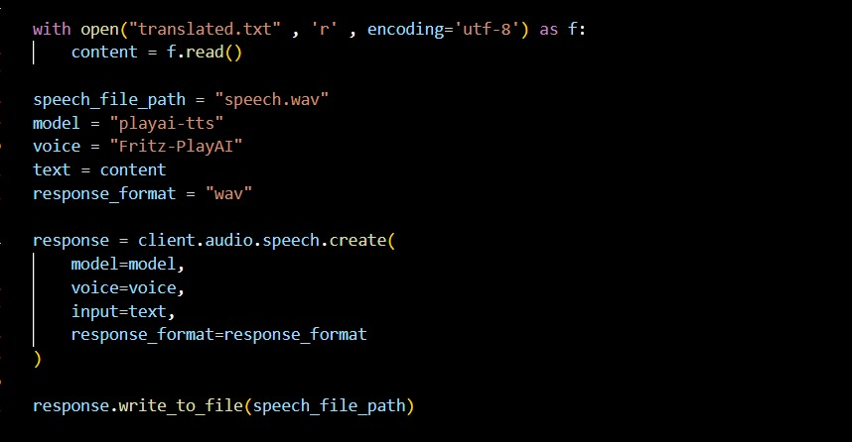

5. Conclusion
The OCR-based assistive glasses integrate both software intelligence and compact hardware design to deliver real-time text recognition and translation for the visually impaired.
By combining ESP32-CAM, PaddleOCR, GoogleTranslator, and Groq TTS, the project demonstrates a functional prototype capable of converting text into speech,
enabling accessibility and independence for users in real-world environments.

References
• PaddleOCR Documentation – Baidu AI Open Source OCR Toolkit,
Available: https://github.com/PaddlePaddle/PaddleOCR
• OpenCV Documentation – Open Source Computer Vision Library,
Available: https://docs.opencv.org/
• Google Translator API – Deep Translator Python Library,
Available: https://pypi.org/project/deep-translator/
• Groq API – Text-to-Speech and AI Inference API by GroqCloud,
Available: https://console.groq.com/docs
• ESP32-CAM (AI Thinker) Datasheet,
Espressif Systems, 2021.
Available: https://www.espressif.com/en/products/modules/esp32-cam
• PAM8610 Audio Amplifier Datasheet,
Diodes Incorporated, 2017.
Available: https://www.diodes.com/assets/Datasheets/PAM8610.pdf
• LM2596 Buck Converter Module,
Texas Instruments, 2016.
Available: https://www.ti.com/product/LM2596
• Battery Management System (BMS) for 2S Li-Ion Batteries,
Shenzhen Hentronics Co. Ltd., 2022.
Product datasheet available on https://www.aliexpress.com
• EasyEDA Online Circuit Design Tool,
Available: https://easyeda.com
• Python Official Documentation,
Python Software Foundation,
Available: https://docs.python.org/3/

